Lab Report
On
“CLOUD COMPUTING”

In partial fulfillment of the requirements for the degree of
Bachelor of Computer Applications

Submitted by:
Anjan Khadka (113102067)

Under the esteemed guidance of
Sujan Poudel
Course Instructor


FACULTY OF HUMANITIES AND SOCIAL SCIENCE
SWASTIK COLLEGE
CHARDOBATO, BHAKTAPUR, NEPAL

Acknowledgement
I would like to express my sincere gratitude to Mr. Sujan Poudel, our course instructor, for his valuable guidance and support throughout these laboratory sessions. His clear explanations and practical instructions helped me understand the concepts of cloud computing, Azure services, virtualization, and server configuration. I am thankful for the knowledge and skills gained through these practical exercises. I also appreciate the time and effort provided by our instructor to help us complete the labs successfully. These laboratory sessions gave me an opportunity to apply theoretical knowledge in a practical environment. I am grateful to my classmates for their cooperation and support during the practical work. Their discussions and assistance made the learning process more effective. I would also like to thank everyone who directly or indirectly supported me in completing this report. Finally, I am thankful for the opportunity to gain practical experience through these laboratory exercises.

Table of Contents
Acknowledgement 2
Lab 1: Getting Started with Azure 4
Lab 2: Azure Storage Services 7
Lab 3: Azure Virtual Machines 10
Lab-4 NGIX Configuration 14
Lab-5 Virtualization 23
Lab-6 Installing Linux Mint on VMware Workstation 29

Lab 1: Getting Started with Azure
Objective: To understand the Azure Portal, subscription model, resource groups, and basic cloud services.
Tasks:
1. Create an Azure Account
- Visit: https://azure.microsoft.com/en-us/free/students
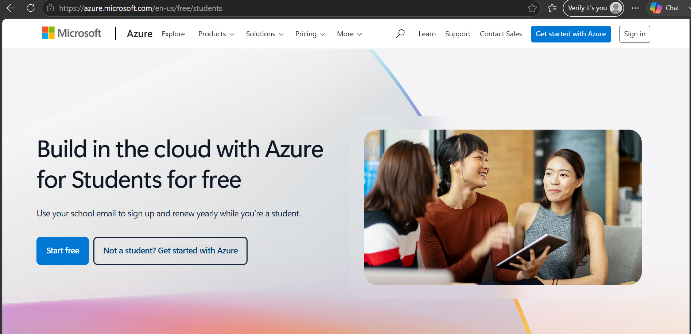

Click Start Free and sign in with a Microsoft account (use a school/university email).
- Select Student Option to get $100 credits via Azure for Students.
- Complete the sign up and verification (phone number + identity verification).
Note: No credit card is needed for student accounts.
2. Explore Azure Portal and Cloud Shell
- Login to the Azure Portal.
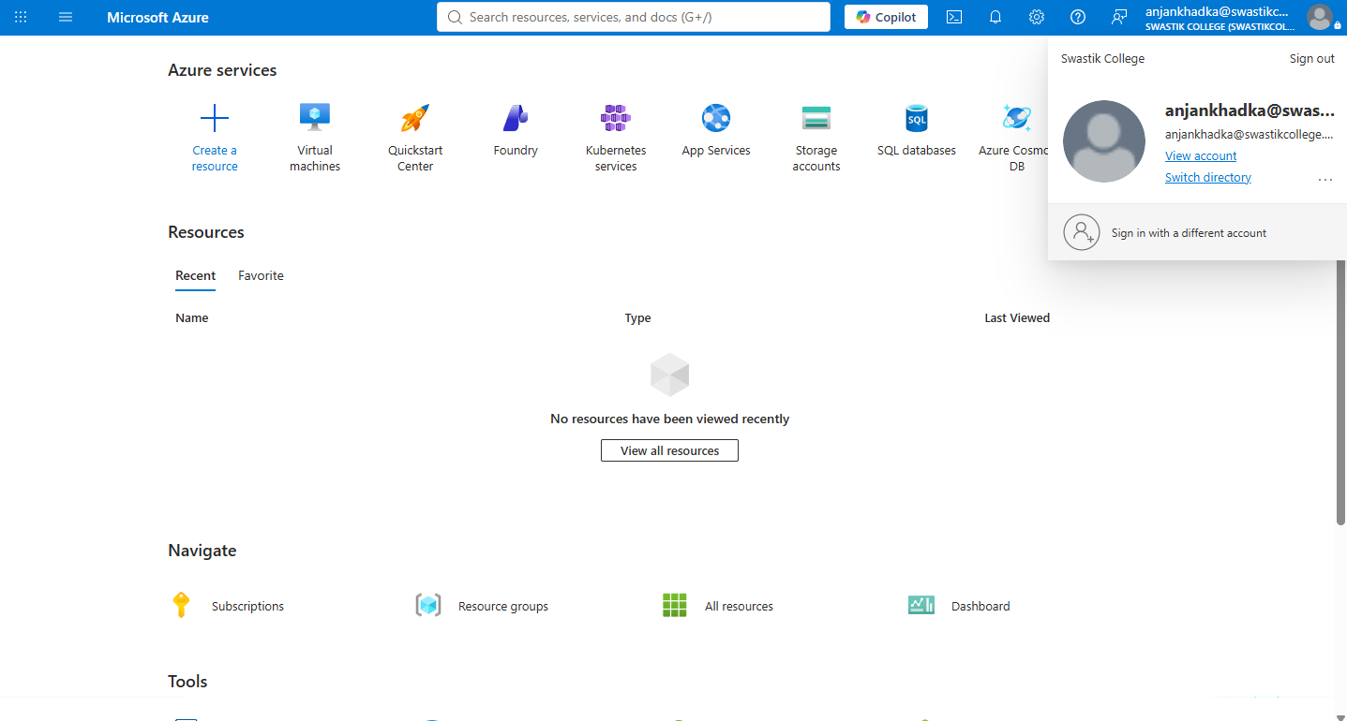

- Familiarize yourself with:
  - Dashboard
  - Resource Groups
  - All Services
  - Marketplace
- Click on Cloud Shell (top-right menu bar → terminal icon)
  - Choose Bash (or PowerShell)
  - Set up Cloud Shell storage if prompted
Tip: Cloud Shell comes preinstalled with Azure CLI.
3. Create a Resource Group
A resource group is a logical container for your Azure resources.
- Via Portal:
- Go to Resource Groups → Create
- Resource Group Name: lab1-rg
- Region: East US (or nearest region)
4.Verify Azure Subscription
- Go to Subscriptions and verified the Azure for students subscription.
- Confirmed that the subscription status was Active.
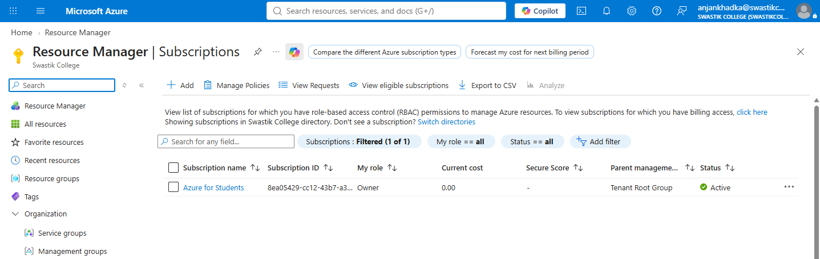

Lab 2: Azure Storage Services
Objective:
To Learn to create and manage Azure Blob Storage, including uploading files and accessing them via public URLs using both the Portal and Azure CLI.
Via Portal:
- Go to Storage accounts → Create
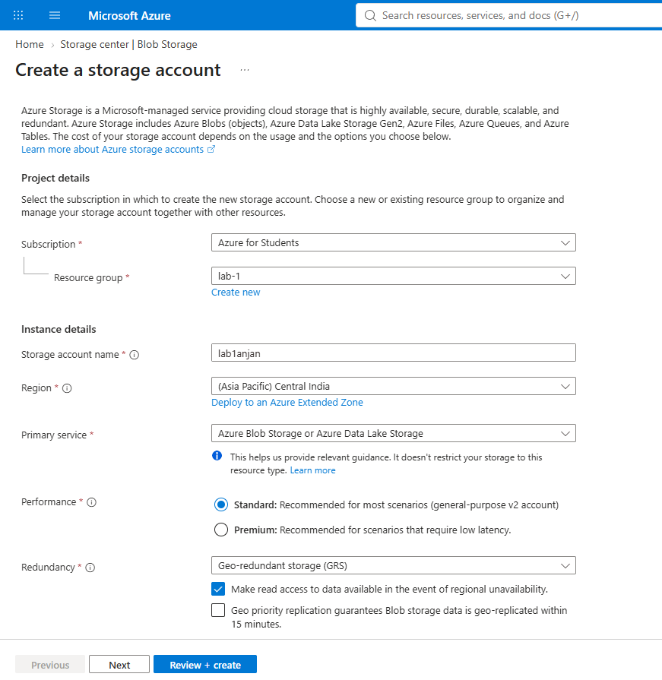
- Fill in the details:
  - Subscription: (Select your active subscription)
  - Resource Group: (or create a new one)
  - Storage Account Name: (must be globally unique) [lab1anjan]
  - Region: East US (or your preferred region) [(Asia Pacific) Central India]
  - Performance: Standard
  - Redundancy: Locally-redundant storage (LRS)
- Click Review + Create, then Create
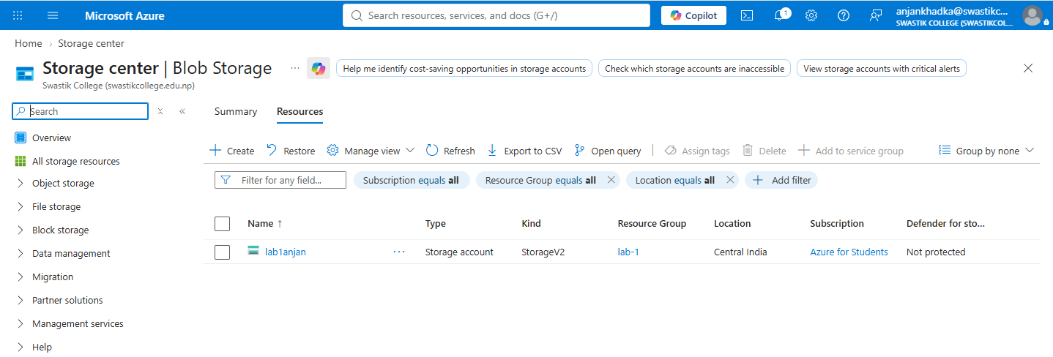

2. Create a Blob Container
Via Portal:
- Navigate to your newly created Storage Account
- Under Data storage, select Containers
- Click + Container
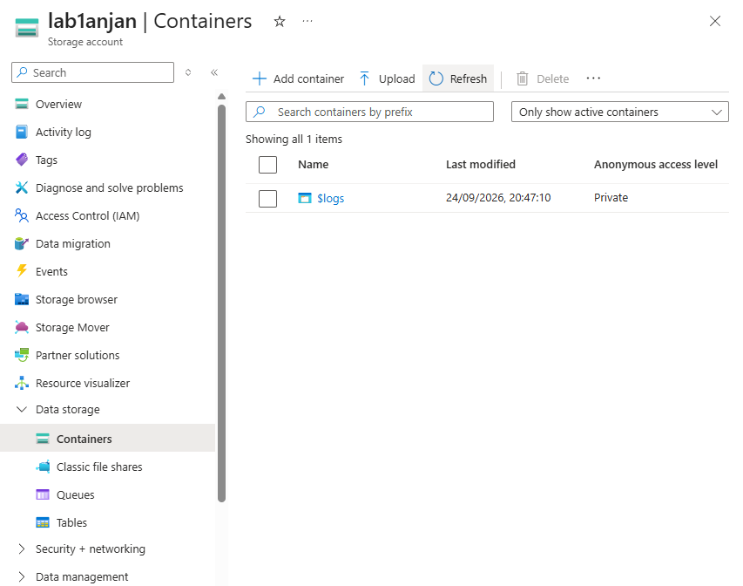

Lab 3: Azure Virtual Machines
Objective:
To Deploy a Linux virtual machine on Azure, connect to it via SSH, and host a static website using Apache or Nginx.

1. Create a Linux-based VM
Via Portal:
- Go to Virtual Machines → Create
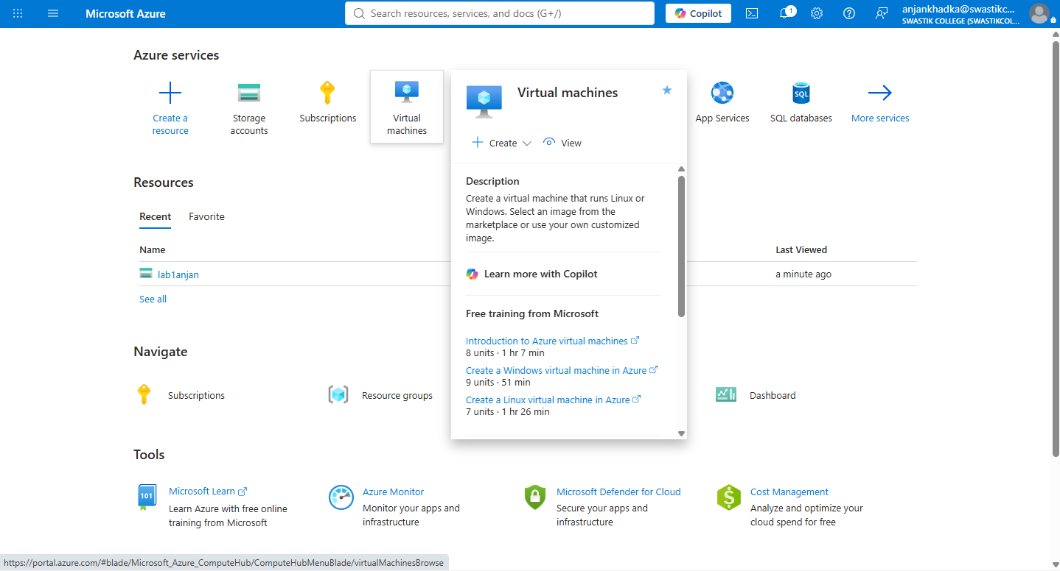
- Fill in the following:
  - Subscription: Your active one
  - Resource Group: lab-1
  - VM name: anjan-vm
  - Region: East US (or nearby)
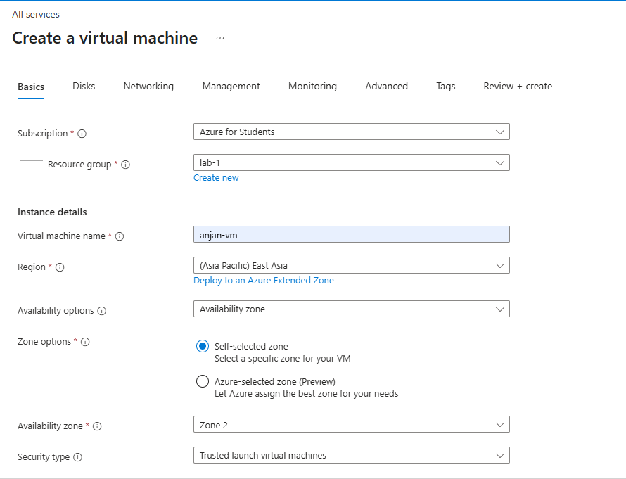
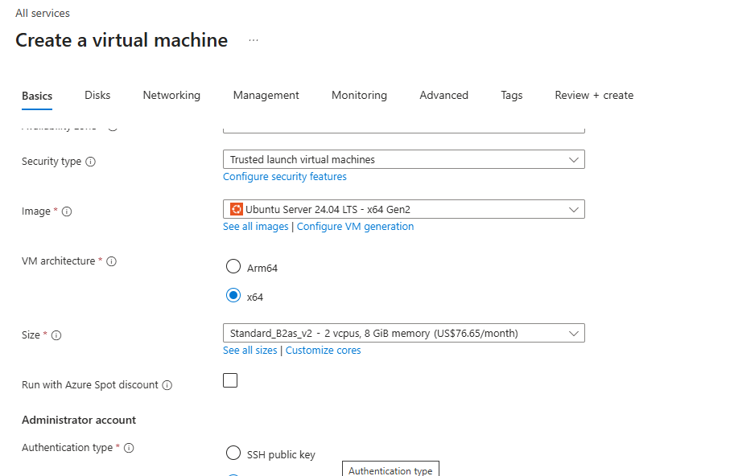
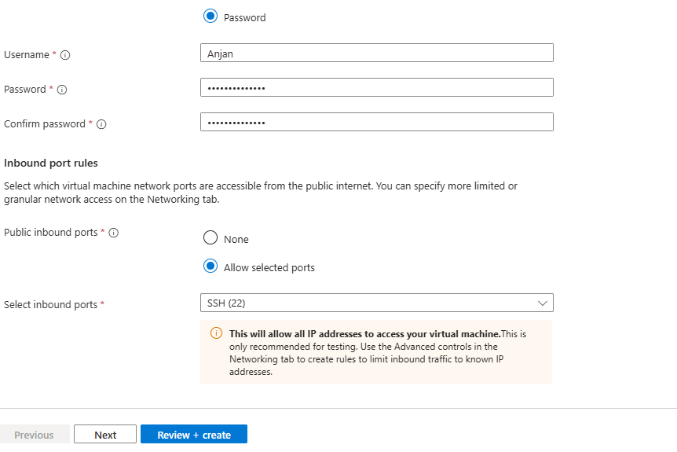
- After deployment, go to the VM → Note down the Public IP address
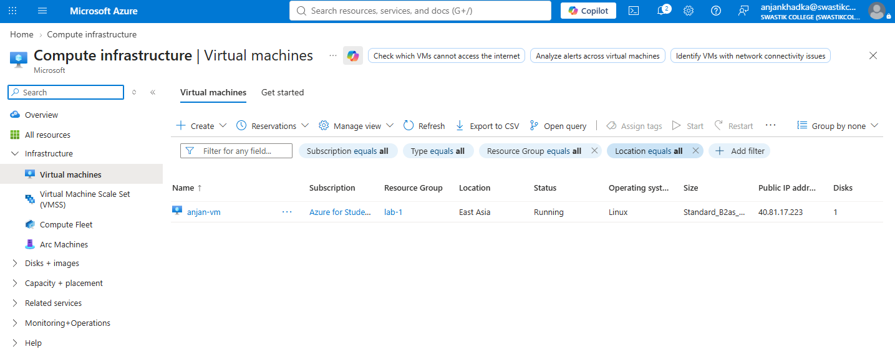
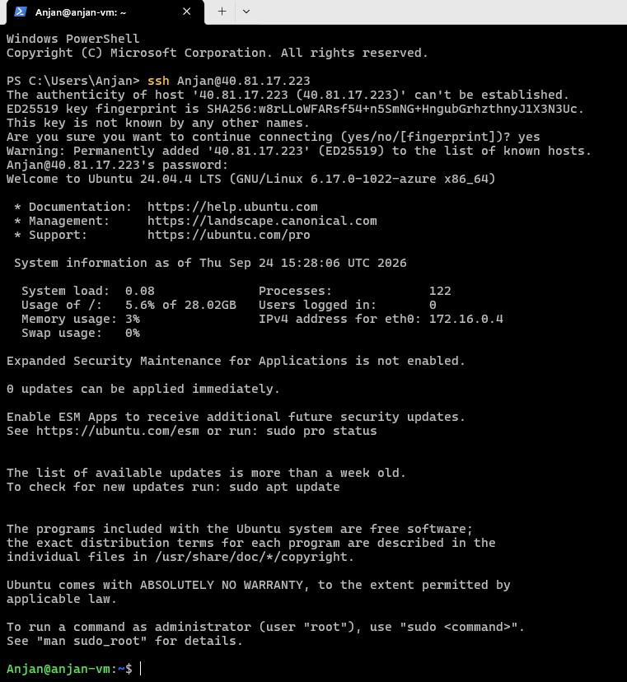

Lab-4 NGIX Configuration
1. Connect to the Virtual Machine
- Connected to the Azure VM using SSH.
- Verified successful access to the Linux environment.
ssh <host-name>@<ip-address>
ssh Anjan@40.81.17.223
bcA-laB12345

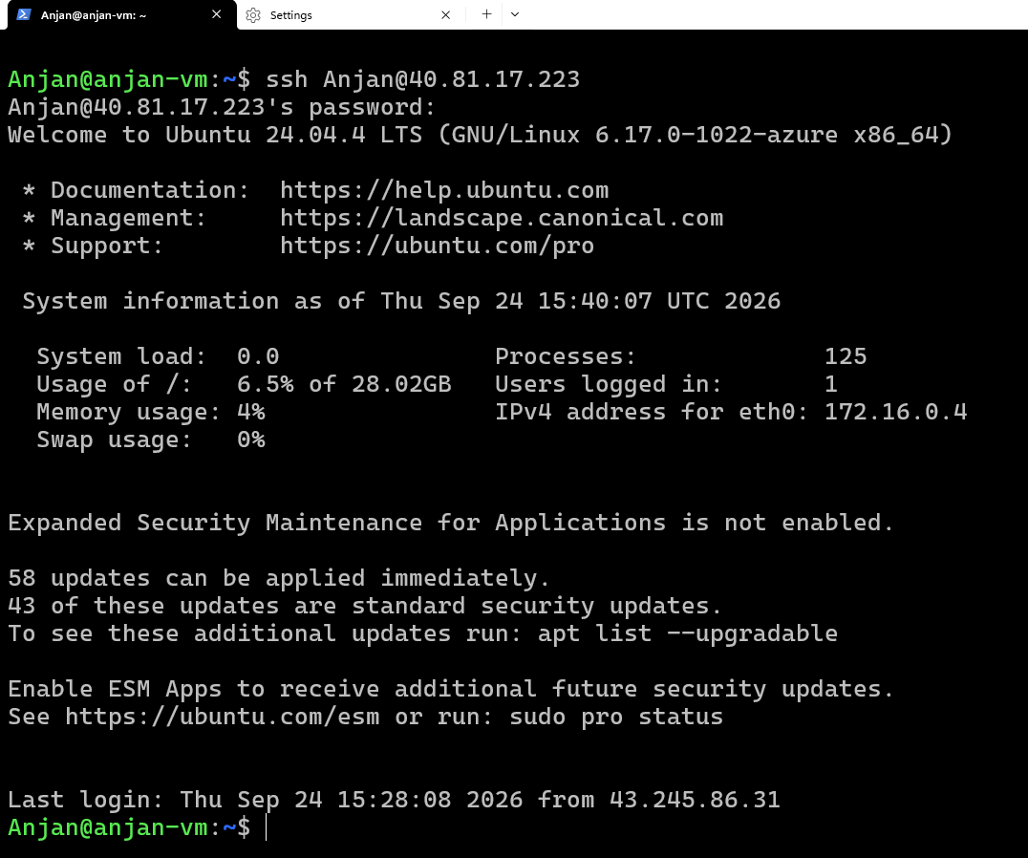

2. Install NGINX
- Updated the system packages.
- Installed NGINX and verified that the service was running successfully.
sudo apt update
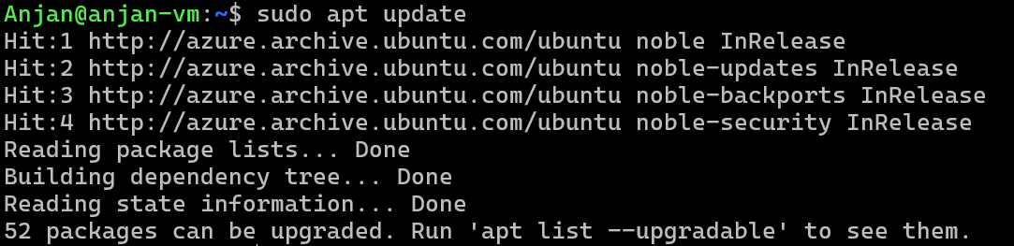
sudo apt install nginx -y
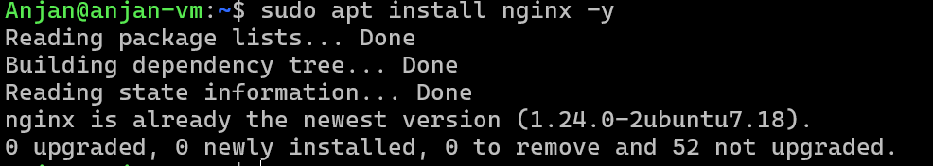
sudo systemctl status nginx
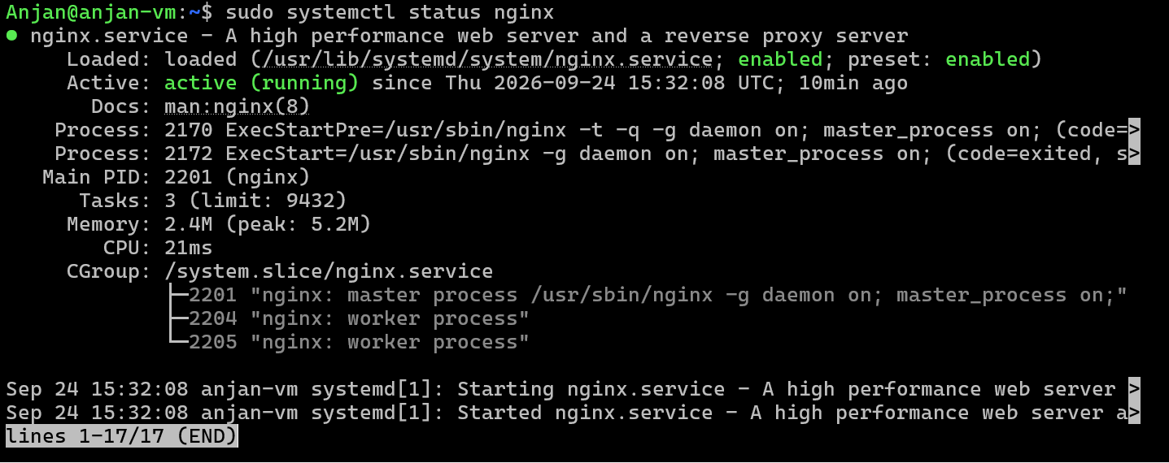

3. Connect GitHub
- Generated an SSH key on the virtual machine.
ssh-keygen -t ed25519 -C
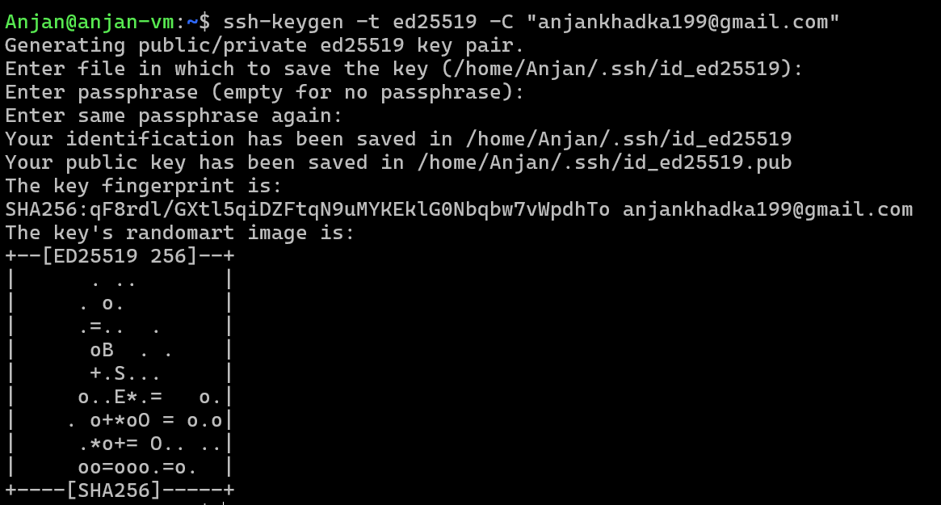
- View and copy your public key:
cat ~/.ssh/id_ed25519.pub
- Add it to GitHub → Settings → SSH and GPG Keys → New SSH Key.
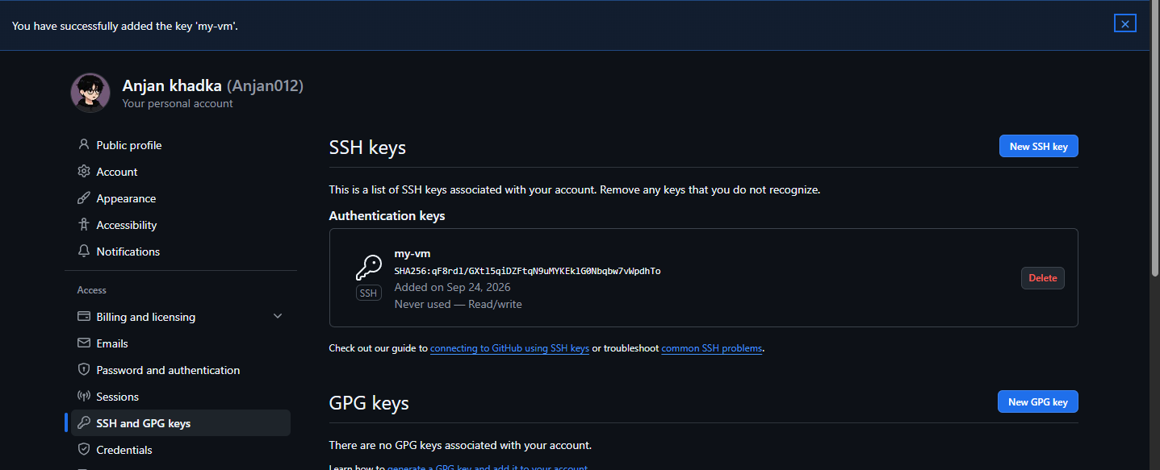
- Tested the SSH connection with GitHub:
ssh -T git@github.com

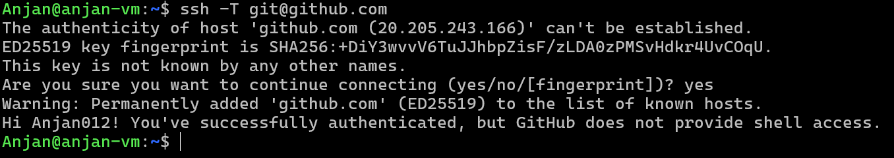
4. Clone the Project
- Navigate to the directory where you want the project:
cd /var/www/

- Cloned the required project repository from GitHub.
sudo git clone git@github.com:username/repository.git

- Configured the required permissions for the project directory.
sudo chown -R bca-lab:bca-lab /var/www

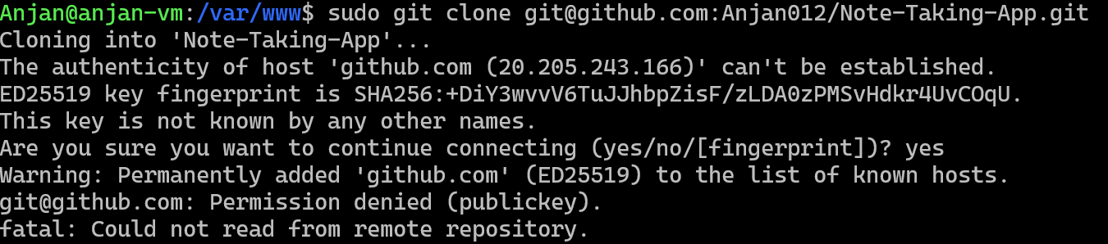

- Installed the required project dependencies.
Go into the project folder:
cd repository
Install dependencies (examples):
Node.js (Frontend/Backend)
- Install node

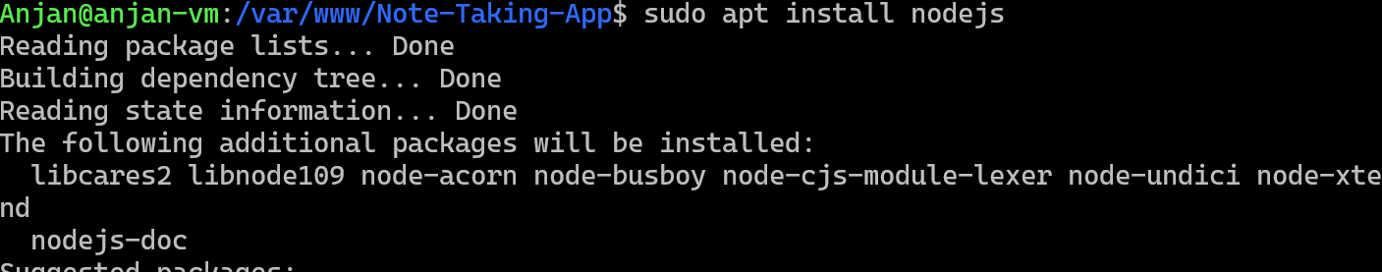

npm install

- Install npm inside VM
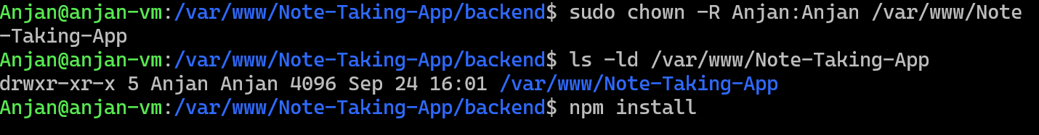
5. Configure NGINX
- Go to NGINX's site-available directory:
cd /etc/nginx/sites-available/
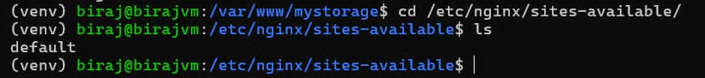
- Create a config file for your project:
sudo nano project1.conf
Configured NGINX as a reverse proxy to forward requests to the application. (Adjust port and folder paths as needed)
server {
listen 80;
server_name your_domain.com;

location / {
proxy_pass http://127.0.0.1:8000; # Your app port
proxy_set_header Host $host;
proxy_set_header X-Real-IP $remote_addr;
proxy_set_header X-Forwarded-For $proxy_add_x_forwarded_for;
proxy_set_header X-Forwarded-Proto $scheme;
}
}

Example
== We need a domain name for this purpose so we are using the free duckdns.org domain for the lab.
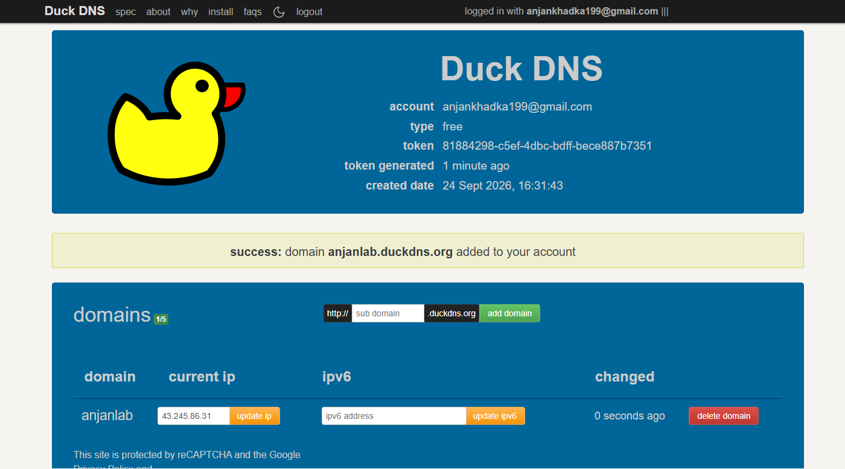

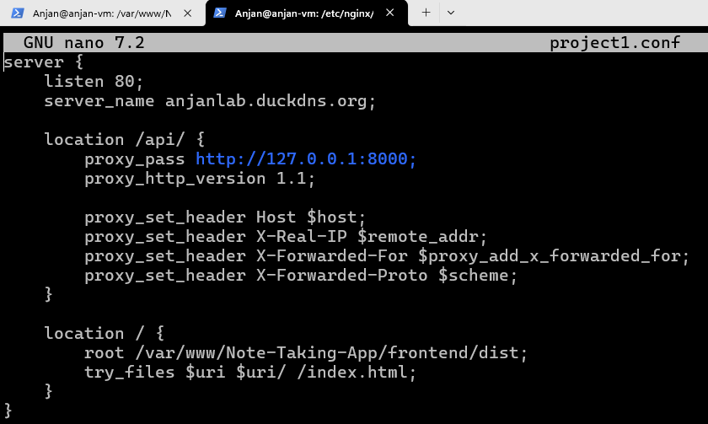
- Create a Symlink to Enable the Site
Link your config from sites-available to sites-enabled:
sudo ln -s /etc/nginx/sites-available/project1.conf /etc/nginx/sites-enabled/

- Test NGINX Configuration
Check for syntax errors:
sudo nginx -t

If everything is OK, proceed.
6. Reload or Restart NGINX
- Apply the changes:
sudo systemctl reload nginx
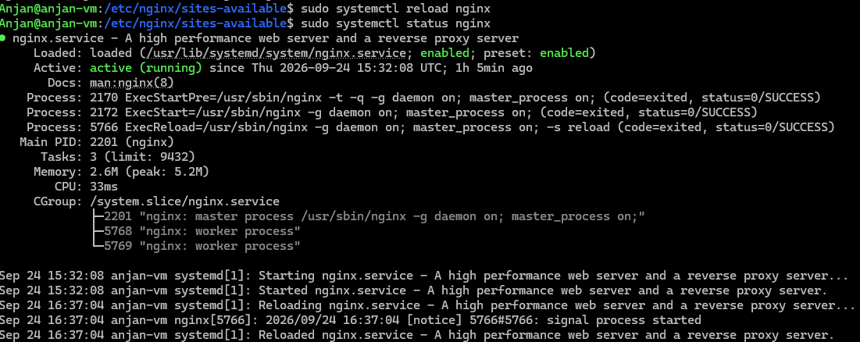
Or full restart:
sudo systemctl restart nginx
Check the domain you have configure to see apply changes on the domain you configured
http://anjanlab.duckdns.org/

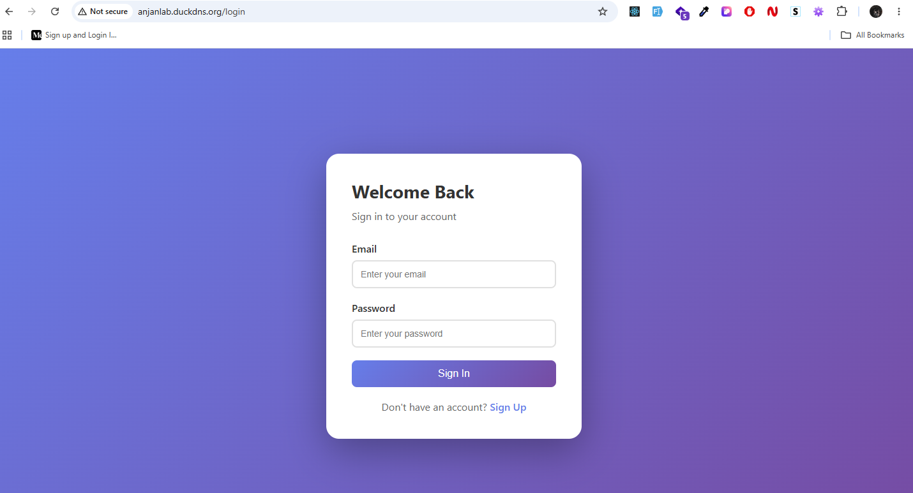

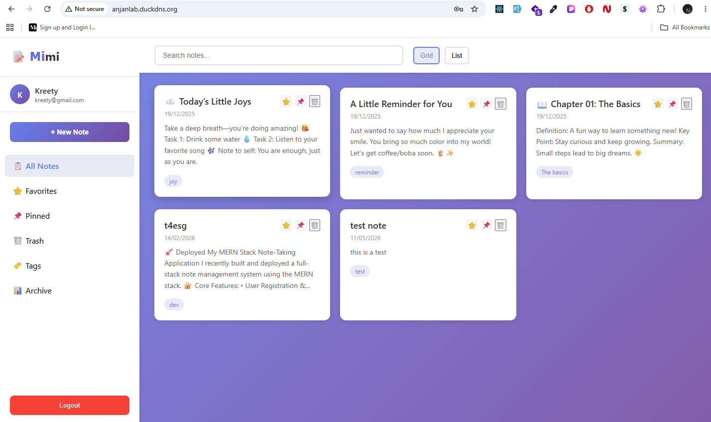

Lab-5 Virtualization
Objective:
To install and configure virtualization software (VMware or VirtualBox) on a local machine and create multiple virtual machines.
Tools Used:
- VMware Workstation
- VirtualBox
In this practical, we will install and configure Linux Mint as a virtual machine (VM) using VirtualBox and VMware Workstation. Follow the step-by-step instructions provided for each tool.
1. Installing Linux Mint on VirtualBox
Step 1: Install VirtualBox
- Download VirtualBox from the official website.
- Install VirtualBox by following the on-screen instructions.
- Open VirtualBox after installation.
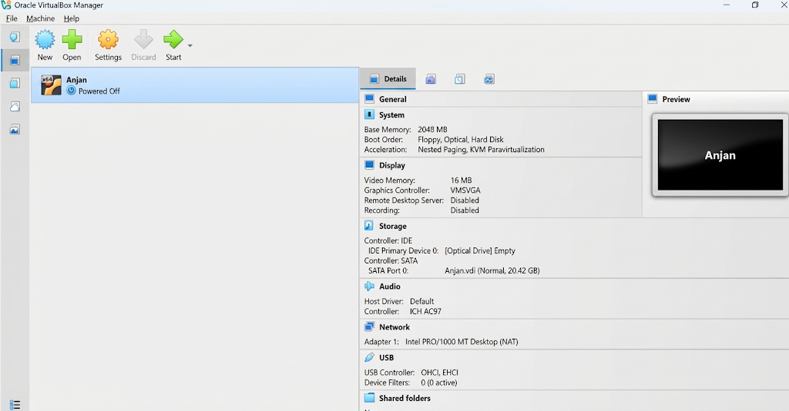

Step 2: Create a New Virtual Machine
- Click on "New" to create a new virtual machine.
- A pop-up window will appear. Configure the following:
    - Name: Enter a name for the VM (e.g., "Linux Mint").
    - Folder: Choose a location to store the VM files.
    - ISO Image: Select the Linux Mint ISO file.
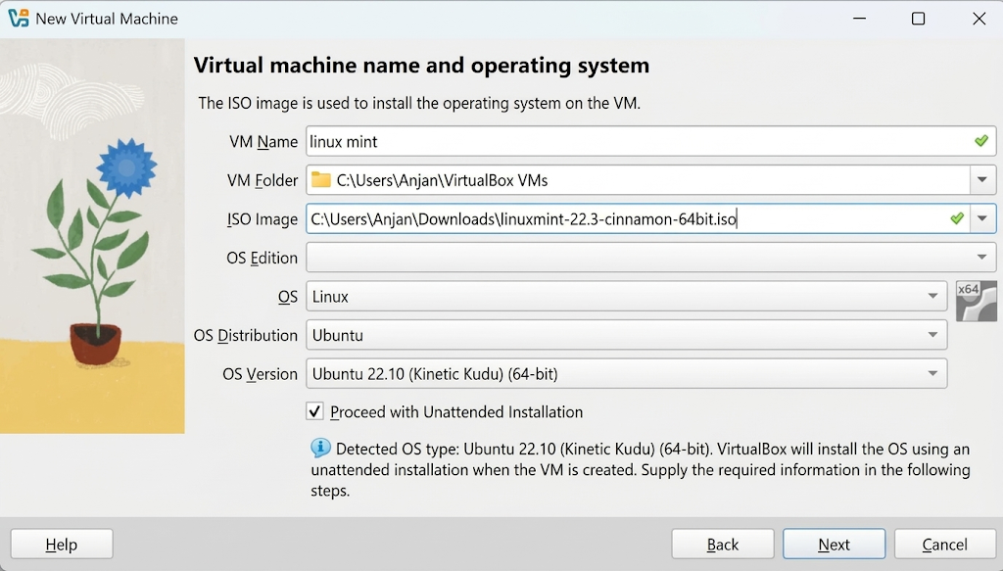
Step 3: Configure System Settings
- Set up username, password, and hostname for the VM.
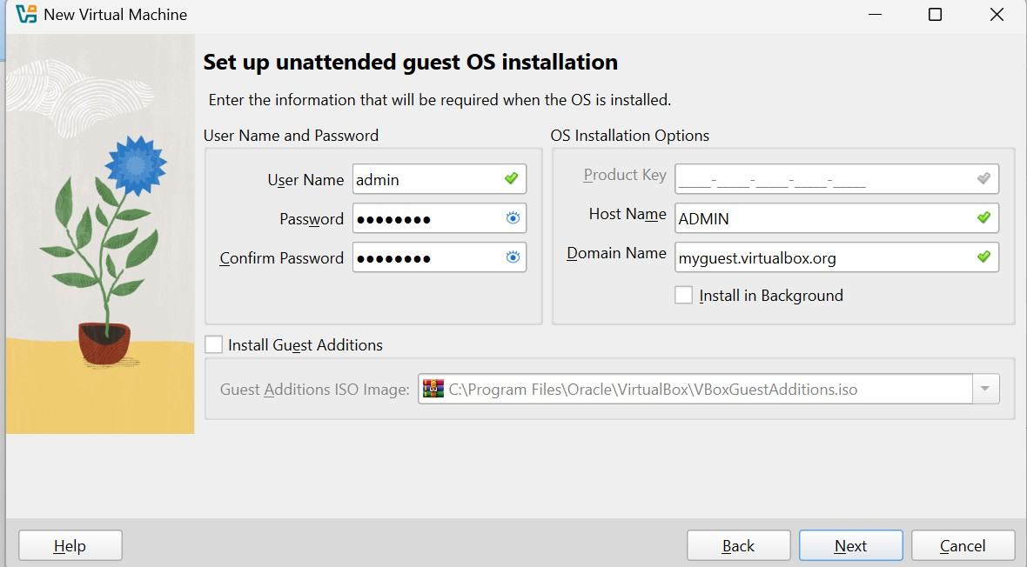
- Customize hardware resources based on system requirements:
      - Memory (RAM) allocation
      - Processor (CPU) cores
      - Storage capacity
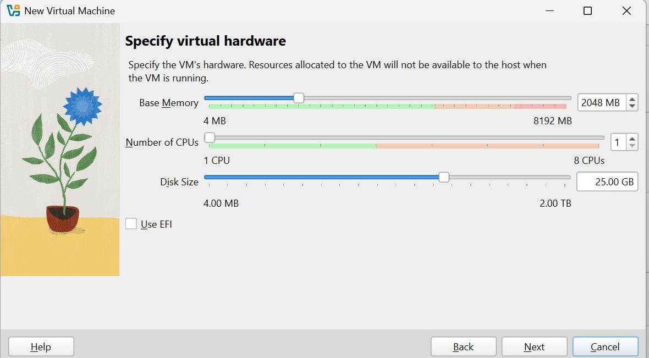

Step 4: Finalizing Setup
- Review the summary of the virtual machine configuration.
- Click "Finish" to complete the setup.

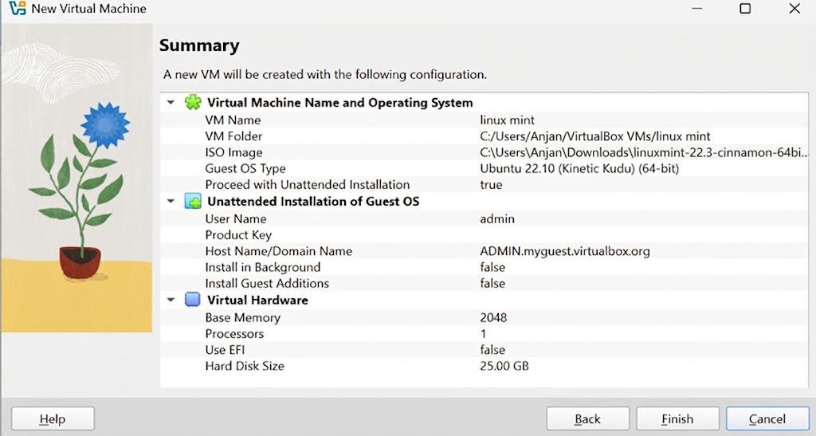
Step 5: Installing Linux Mint
    - Start the virtual machine from the VirtualBox main interface.
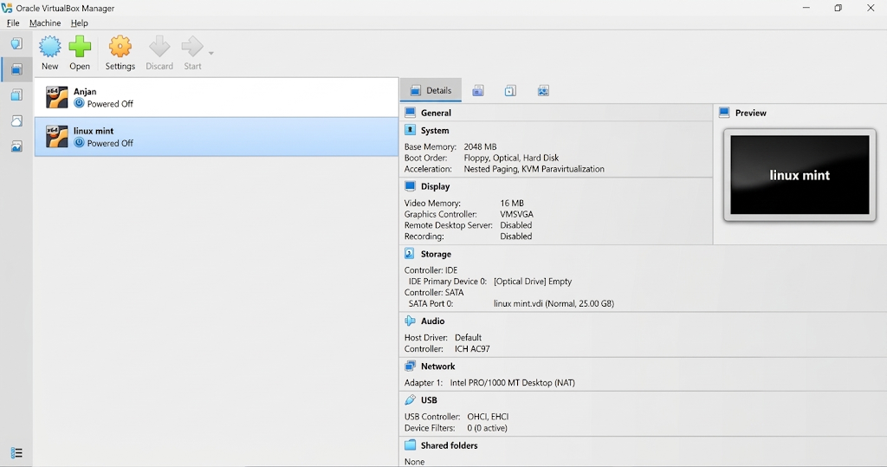
    - The installation process for Linux Mint will begin.
    - Follow on-screen instructions:
        - Pick a username and password.
        - Continue with the installation process.
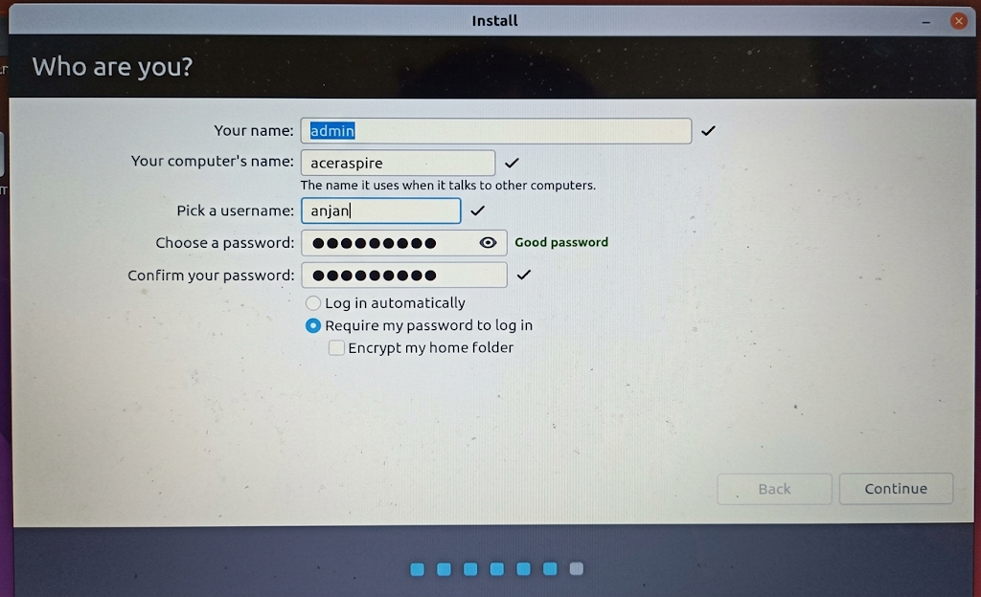
  - Once completed, Linux Mint will successfully launch inside VirtualBox.
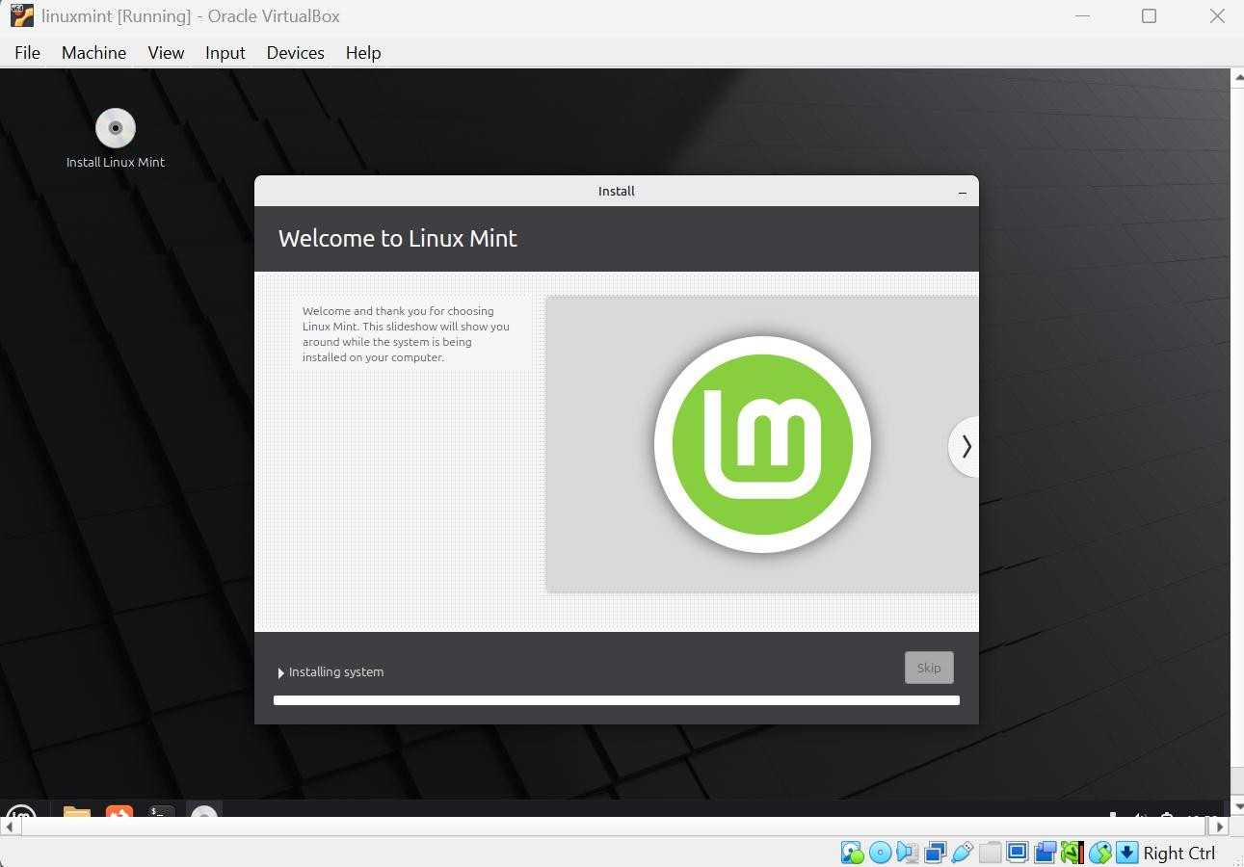
  - Successfully launch “Linux Mint” Operating system on Virtual Box
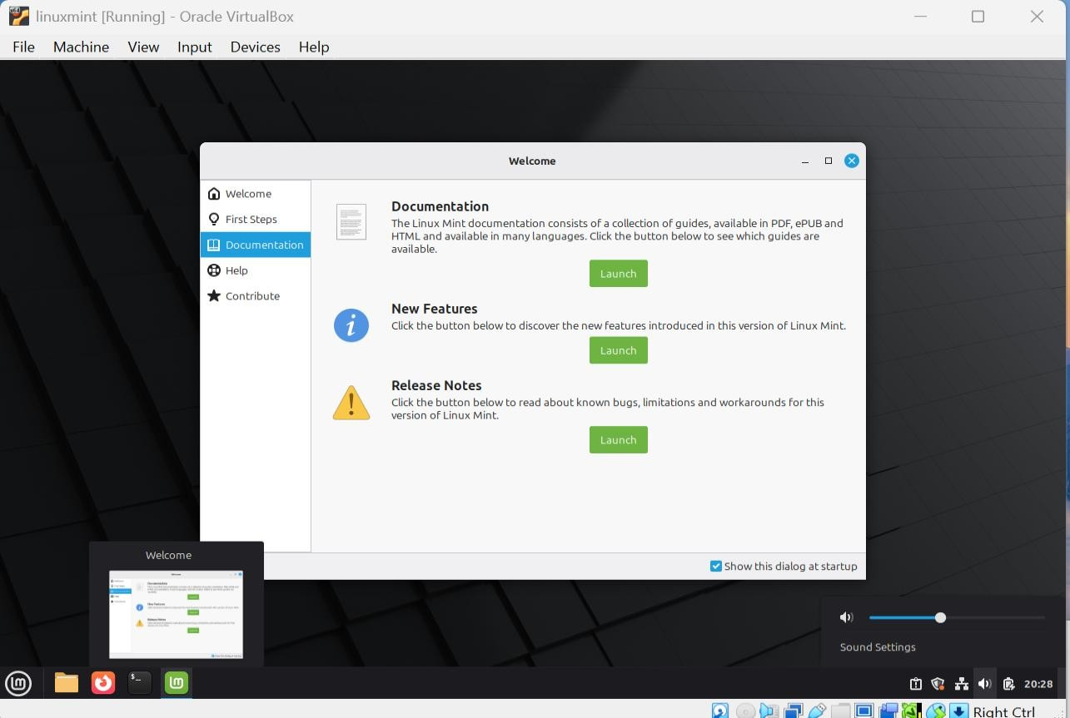

Lab-6 Installing Linux Mint on VMware Workstation
Step 1: Install VMware Workstation
- Download VMware Workstation from the official website.
- Install VMware Workstation and launch the application.
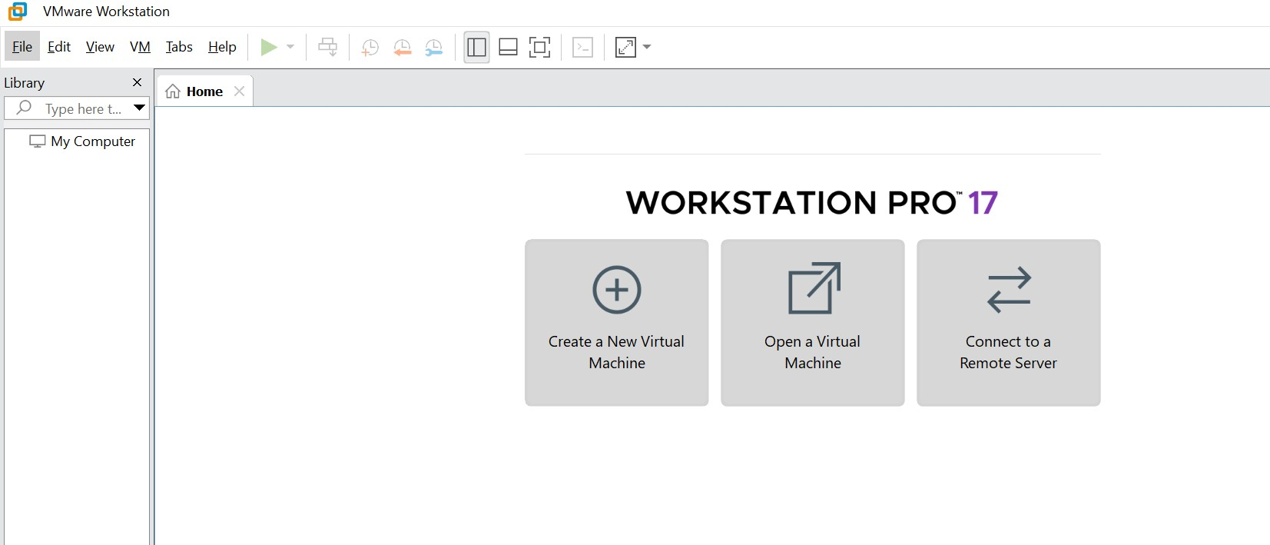
Step 2: Create a New Virtual Machine
- Click on "Create a New Virtual Machine".
- Choose the third option:
a. "I will install the operating system later" and click Next.
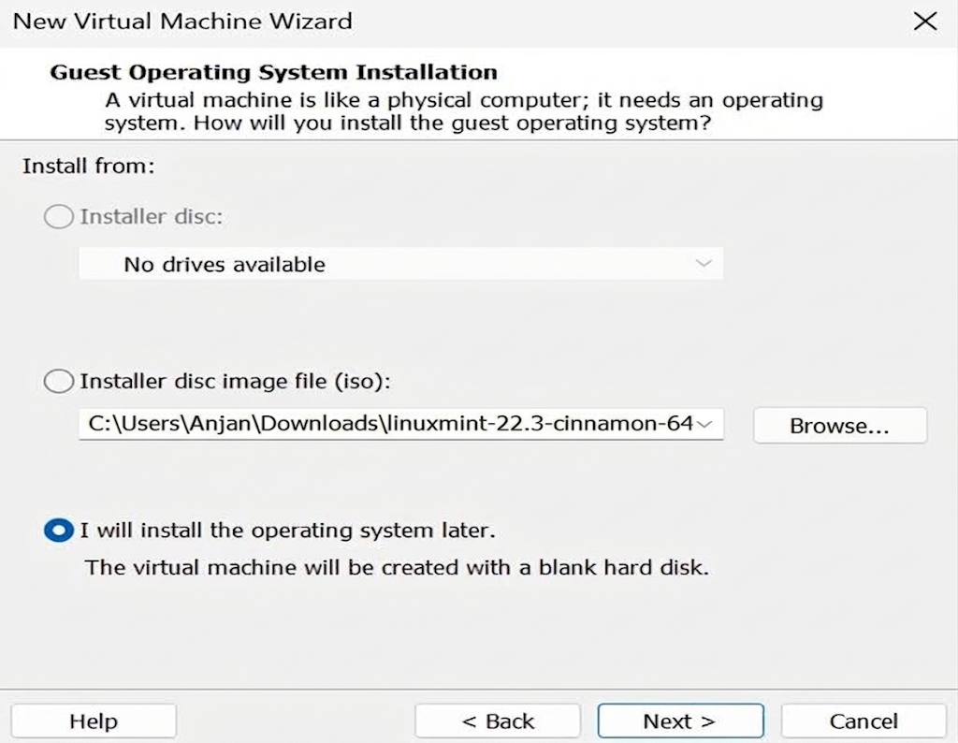

Step 3: Configure VM Settings
- Select the Guest Operating System:
  - Choose Linux as the OS type.
  - If Linux Mint Cinnamon is not listed, select Ubuntu 64-bit (closest version).
- Click Next.
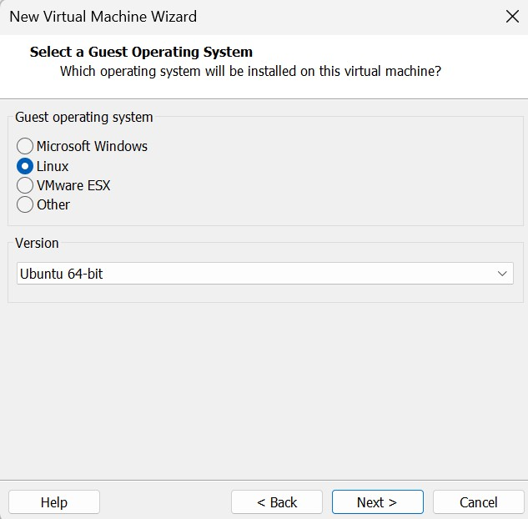
Step 4: Set VM Name and Storage Location
- Enter a name for the virtual machine (e.g., "linuxmint").
- Specify a location to save the VM files.
- Click Next.
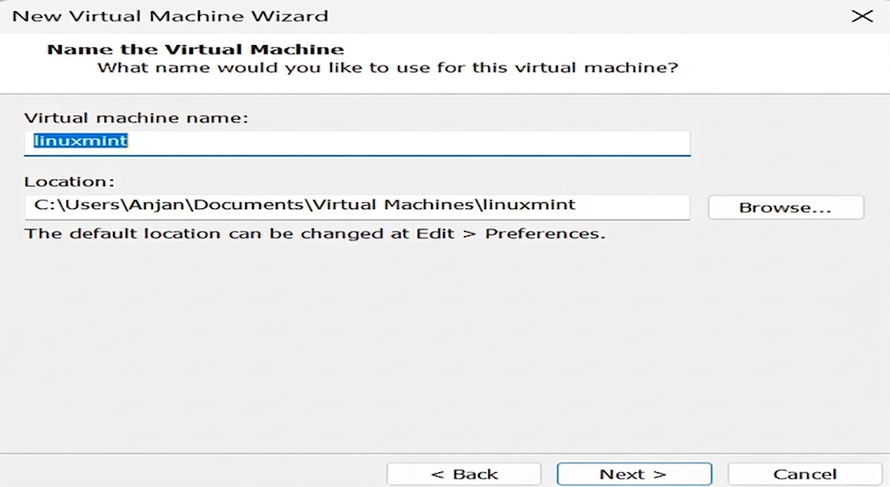
Step 5: Specify Hard Disk Capacity
- Set the desired disk size (recommended: 20GB or more).
- Click Next.
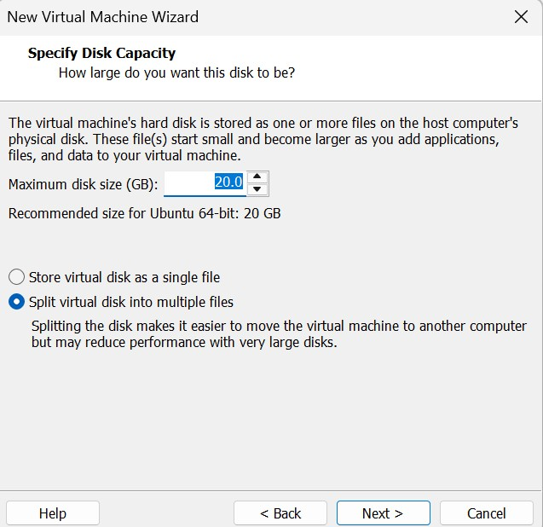
Step 6: Customize Hardware Configuration
- Adjust Memory (RAM), Processors, and other hardware settings.
- Locate the ISO image file:
  - Go to New CD/DVD (SATA).
  - Browse and select the Linux Mint ISO file.
  - Click Close.
- Click Finish to complete the setup.
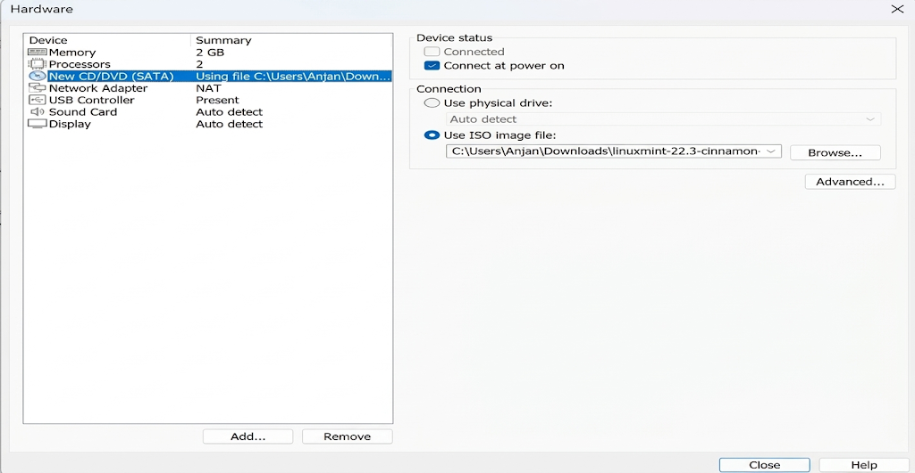
- Do finish.
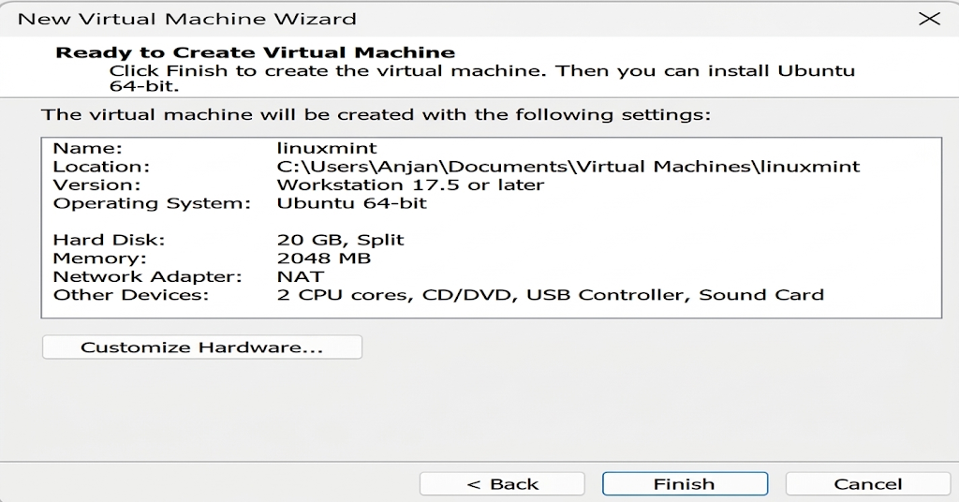

Step 7: Start the Virtual Machine
- Select the newly created VM from the list.
- Click "Play Virtual Machine" to start it.
- The Linux Mint installation process will begin.
- Complete the setup by creating a username and password

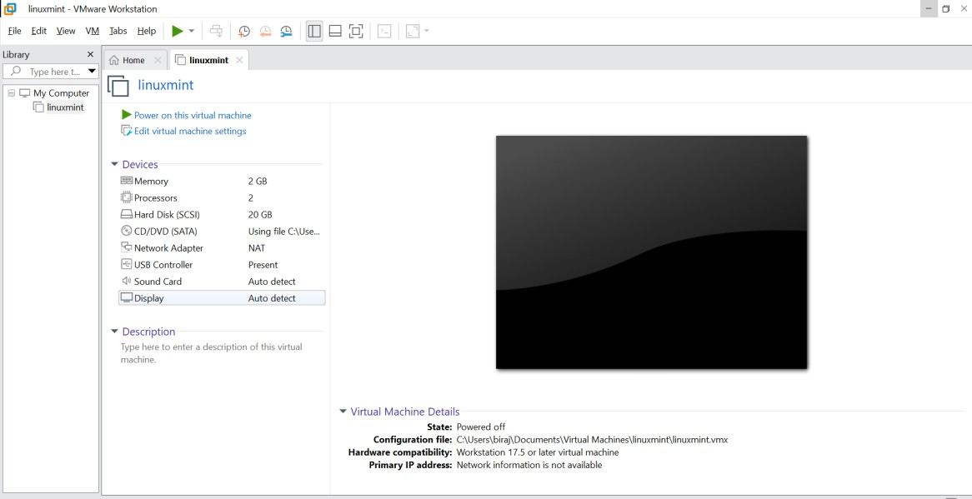

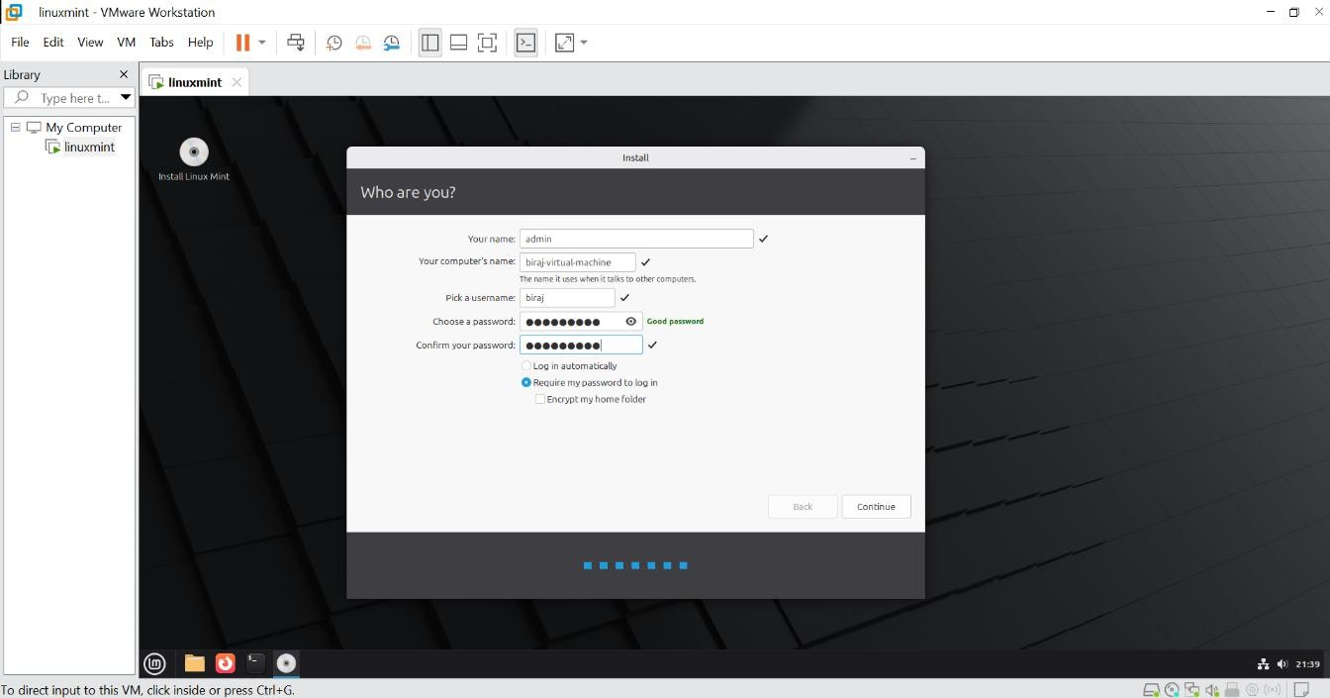
Once the installation is finished, Linux Mint will successfully launch on VMware Workstation.
